Version changes for contact waterfall:

1. Add a web-search enrichment stage (Brave)
A search API can find pages that crawler would not discover from the startup homepage, such as university biographies, competition pages, accelerator profiles, conference speaker pages, grant announcements, GitHub profiles, PDFs, and archived press releases.
For example, Brave's official Search API supports quoted queries, site: queries, and filetype: searches, and can return extra snippets for richer candidate-page selection.
Configurable:
SEARCH_BACKEND=brave
BRAVE_SEARCH_API_KEY=...
SEARCH_MAX_RESULTS=10
SEARCH_QUERIES_PER_FOUNDER=5

2. Add Hunter as an optional fallback
Hunter's official API provides:
- Domain Search;
- Email Finder;
- Email Verifier;
- person and company enrichment.
Its Domain Search can return personal and generic addresses found for a domain, while Email Finder accepts a domain plus first and last name. Hunter also exposes sources and confidence information and has a verification endpoint.
Example:
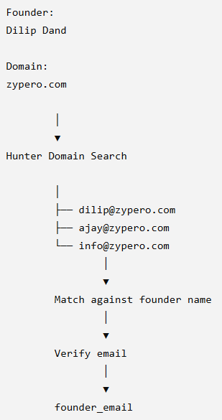
Only call it when the free web pipeline fails, to control API costs.

3. Add Apollo as a second-stage waterfall
Apollo can be particularly useful when the pipeline has a founder identity but the startup's public web presence is poor.
Apollo's People Enrichment endpoint can use combinations of:
- full name;
- first and last name;
- employer;
- company domain;
- LinkedIn URL.
Its documentation explicitly notes that providing more identifying information improves the chance of a correct match. It also supports optional email waterfall enrichment across additional data sources.

4. Improve domain resolution before searching for email
From:
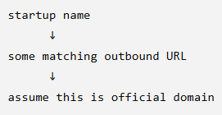
Changes to:
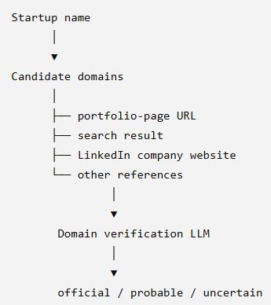
New fields:
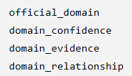
Possible domain_relationship values:
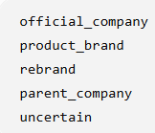

5. Replace static-path crawling with link-ranked crawling
Previous pipeline attempts URLs such as:
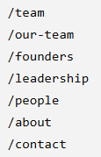
This works for conventional websites but misses sites with URLs such as:
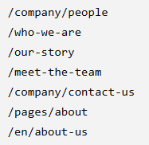
New strategy:
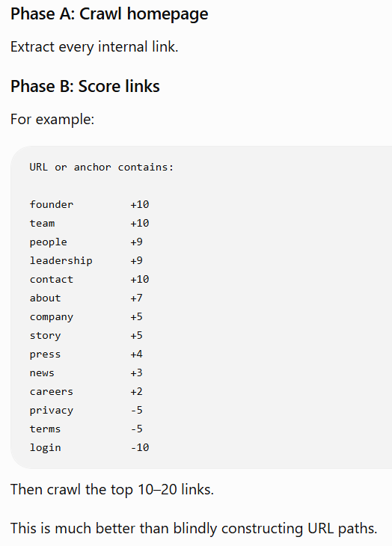
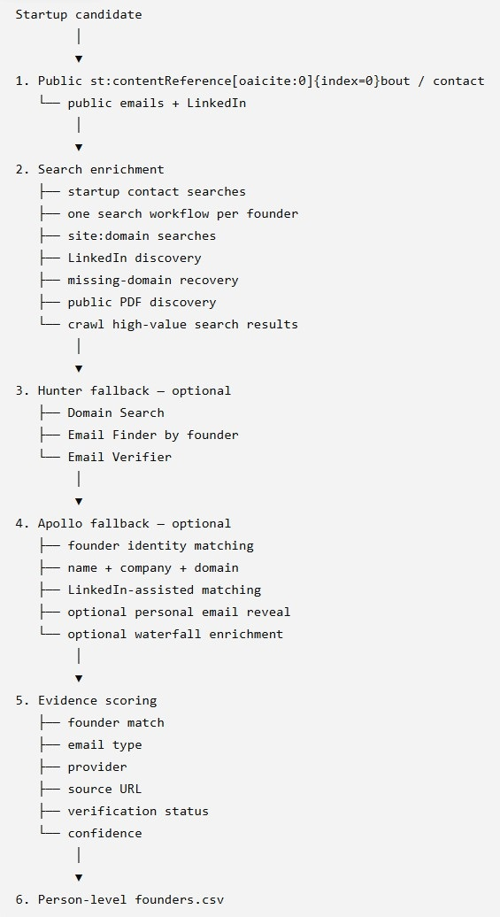

What does priority mean?

1. Source priority: Priority
This is the priority of the website source in the seed list.
For example:
Priority | Meaning
1 | Highest-value source; crawl first | Official university startup portfolio  Official incubator portfolio  Demo Day participant page  Student startup competition finalists
2 | Strong source | University entrepreneurship news  Accelerator alumni page  Innovation centre showcase
3 | Useful secondary source | General startup directory  Government ecosystem directory  Broad accelerator portfolio
4+ | Lower-priority or broader source | General startup news  Broad business directories  Less targeted ecosystem sources

2. Candidate priority: priority_score
The score combines things such as:
eligibility confidence
+
innovation
+
scalability
+
international potential
+
competition fit
+
source quality
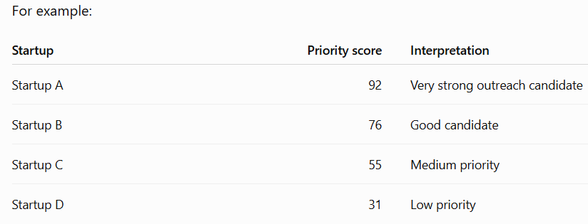

How ere the linkedin url obtained?
LinkedIn URLs are gathered from four sources across the pipeline, and they're all from public page text / search results — the pipeline never logs into or scrapes LinkedIn itself (that's blocked). Here's each source, in the preference order the code actually uses (_apply_findings, contact_enrichment.py:446-457):

1. LLM extraction (highest priority)
During the extraction step, the LLM reads the seed/startup page and fills each founder's linkedin_url field (FounderEvidence.linkedin_url in schemas.py) whenever a linkedin.com/in/... link for that person appears in the page text. _apply_findings explicitly "prefers the founder's LinkedIn already extracted by the LLM" over everything else.

2. The startup's own website (Stage 1 crawl)
While crawling the startup site, extract_linkedin_urls() regex-scans every page's markdown:
LINKEDIN_PERSON_RE = .../in/... # personal profile -> founder_linkedin_url
LINKEDIN_COMPANY_RE = .../company/... # company page -> company linkedin_url
The first /in/ link found becomes founder_linkedin_url (if the LLM didn't already provide one); the first /company/ link becomes the company's LinkedIn.

3. Web search — Brave (Stage 2)
search_enrichment.py builds an explicit query "Founder Name" "Startup" LinkedIn and then pulls LinkedIn URLs out of the search-result snippets/titles, the result page text, and even the result URLs themselves (extract_linkedin_urls(text + "\n" + result.url)). This is how a founder's LinkedIn is recovered when it isn't on their own site.

4. Apollo (Stage 3, paid)
When Apollo's people_match returns a person, it back-fills founder_linkedin_url if still empty. (Not used in your last run — people_provider was none.)

